Training & Accreditation in Physician Performed Ultrasound
MODULE 1: NEONATAL CRANIAL ULTRASOUND

Purpose of Document

This document describes the process for credentialing Neonatal Intensive Care (NICU) Physicians within Monash Health (MH) to perform Point of Care

- Neonatal Cranial sonography – haemorrhage assessment

Background
Physician performed Point of Care ultrasound (PoCUS) has become an accepted part of clinical management. The immediacy and availability of bedside ultrasound in a variety of clinical contexts means that patient management decisions can be more informed and made earlier. Physician performed cranial ultrasound enables expedited management of patients with suspected intracranial bleeding.
The use of ultrasound by Neonatologists to assist in understanding physiology and to help guide management in the NICU is rapidly expanding (Kluckow 2014, Rath et al 2016), with research demonstrating an important impact on clinical management (Harabor 2015). With appropriate training, clinician performed ultrasound (CPU)/ Point of Care Ultrasound (POCUS) is now practised widely in obstetrics, emergency medicine and adult intensive care and is the standard practice in neonatology in many developed countries (Evans et al 2011). Neonatal intensive care is a dynamic process, involving frequent evaluation, some in real time in preterm neonates with acute deterioration in clinical condition.

The Australasian Society for Ultrasound in Medicine (ASUM) supports the devolution of diagnostic ultrasound to the clinical specialties only where the necessary regulatory environment and infrastructure exist for the supervision of training in the medical and surgical specialties. ASUM states that the training of clinicians in medical ultrasound should be adequately funded and planned with a defined curriculum, standards and scope of practice that appropriately reflects the role of clinical diagnostic ultrasound within a defined specialty (ASUM, 2008).

The Monash Health PoCUS program commenced in 2011, to support the education, training and credentialing of clinicians. The current PoCUS program involves Monash Intensive Care, Monash Imaging and MonashHeart collaborating to ensure excellence in clinician performed ultrasound.

Agreed Scope of Practise
This document describes ultrasound training in Neonatal Cranial Ultrasound for haemorrhage. On-going credentialing is provided in the performance of Cranial ultrasound only.
POCUS will be undertaken by Consultant Neonatologists and fellows for clinical indication of intracranial bleeding in the case of acute neonatal deterioration in clinical condition (cardiorespiratory and/or neurological deterioration).
These examinations will be carried out after hours, weekends and public holidays. They can be undertaken during office hours under direct supervision of Monash Radiology team or Consultant Neonatologist with Monash Health accreditation.
No clinical management decisions or interventional procedures should be based on PoCUS findings without engagement of ultrasound accredited NICU Consultant and formal imaging confirmation.
All ultrasound examinations are to be documented with archived images as per scan protocols. Scan time should not exceed 6 minutes. All PoCUS examinations are to be archived to PACS, enabling scans to be reviewed for clinical, training and quality audit purposes. The clinician must document PoCUS scan findings in the electronic medical record for every examination.

Objectives
At the end of this Neonatal Cranial module, the Physician will be able to:
- Identify the sonographic anatomy of the neonate cranium including the following: Ventricles, anatomy of major sulcal patterns, thalamus, caudate nucleus, corpus callosum, cerebellum, frontal lobes, third ventricle, hippocampus, posterior horns, occipital lobes, right and left caudothalamic groove, right and left sylvian fissure, cerebellum.
- Competently use coronal and sagittal cranial ultrasound windows via anterior fontanelle to demonstrate normal anatomical structures.
- Recognise and diagnose intracranial bleeding with competent assessment of subependymal, intraventricular and parenchymal bleeding.
- Understand appearances of artefacts (e.g. too much gel creating artefact).
- Perform an ultrasound examination per MH Cranial scan protocol.

This document describes:

- A 3 stage process for accrediting Neonatologists to perform Cranial ultrasound
- Initial Training
- Skills Development / Electronic Logbook / MH Accreditation
- Ongoing Quality Audit / Skills Maintenance
- A method for auditing scan quality, maintaining a MH electronic logbook and ongoing accreditation
- A practical competency assessment of the skills necessary to obtain and interpret appropriate ultrasound images for a Cranial examination

STAGE 1 - Initial Training

Neonatologists intending to perform ultrasound within MH are expected to complete:
- Compulsory online ultrasound physics module (external – NSW ECI)
- Appropriate practical ultrasound course (MH internal course or external private course*)
- Have their qualifications and suitability approved by Deputy Director NICU before commencing with PoCUS program
*Note any external PoCUS courses undertaken should be ASUM accredited standard.

STAGE 2- Program Induction/ Skill Development / eLogbook / MH Accreditation

Clinicians who have completed an external training course will undertake a 60 minute induction session by Sonographer educator, prior to practical skills development and commencing scanning at MH. This induction session covers Monash scan protocols, skills brushup, equipment ‘knobology’, infection control, scan archiving & documentation processes. Clinicians who have undertaken the internal course will complete the practical skills development as part of the internal course structure. Practical scanning skills training, mentoring and feedback is offered throughout the completion of Stage 2. Additional self-directed learning is expected including case revision, journal reading and other online resources.

Stage 2 requires the completion of a logbook which documents a minimum of 25 CRANIAL examinations:

- A minimum of 5 cases in logbook must be positive
- An entry is only valid if the physician is the person performing the examination
- Multiple entries of same patient in the same episode of care by a physician is not acceptable
- Physician is to record an adequate series of images as described in examination protocols
- Physician must document ultrasound scan findings for every examination, even if clinically limited or focussed (eg. single view), in the electronic medical record.
- Documentation is required to facilitate adequate patient identification, upload of scan images to PACS, generation of an electronic logbook and quality auditing process based on clinician scan findings
- e-Logbooks are maintained for clinicians by Monash PoCUS program indefinitely & circulated to clinicians periodically as part of quality audit feedback
- All examination images will be transmitted to Monash Imaging for upload to PACS
- Physician will be provided with support & feedback during this training & skills development stage as required

Quality Auditing

Regular auditing will be conducted and data maintained by PoCUS program sonographer educators. Quality audit reports will be provided to PoCUS committee, including Directors of Ultrasound & NICU. Examinations will be qualitatively assessed using a simple system assessing technical adequacy and diagnostic accuracy of examination, with reference to correlative imaging, surgical or clinical findings where available.

eLOGBOOK QUALITY AUDIT FEEDBACK
3 | good scan, accurate diagnosis & technical quality
2 | technical errors, but no misdiagnosis
1 | false negative
0 | false positive

Audit results and comments for clinician feedback will be provided in personal elogbooks maintained for clinicians. A minimum 30 CRANIAL examinations will be audited until a physician achieves MH credentialing. Thereafter, random audit of a minimum 5 examinations will be conducted yearly to ensure maintenance of skill and quality.

Accreditation
Once logbook requirements (minimum scan numbers and positive cases) are completed, a brief practical competency assessment will be conducted by program Sonographer.

Alternative Accreditation Pathways
In certain select situations, alternative accreditation pathways may be considered for approval by the NICU PoCUS governance group.
- Fast tracked ‘grandfathering’ credentialing for clinicians with considerable prior experience, but no formal credentialing. This process would involve Monash Health program induction, practical and image recognition competency assessments & the completion of a minimum of five quality reviewed scans, to be reviewed & considered for approval by committee.
- ASUM CCPU, DDU or other credential holders from external institutions. This process would involve Monash Health program induction, practical competency assessment & the completion of a minimum of five quality reviewed scans, to be reviewed & considered for approval by committee.
Note: Fast tracked ‘grandfathering’ credentialing is dependent on passing both the practical competency assessment and a case-based image recognition MCQ. Clinicians may be signed-off at the end of a 2 hour session which involves competently scanning 5 cranial ultrasounds (as per protocol) & satisfactory performance in both the practical and image recognition assessments. Criteria for practical assessment can be found on page 10 of this document. A satisfactory score is 12 or higher.
To pass the image recognition component a score of 8/10 or higher should be achieved.
If these requirements are not met, the clinician will be required to undertake further training sessions prior to grandfather/fast-track credentialing sign-off (number of sessions at sonographer educator discretion based on demonstrated gaps in knowledge or skills)

STAGE 3: Ongoing Skills Maintenance

After completing the MH Accreditation process, the Emergency Physician is able to perform CRANIAL scans within MH. In order to maintain MH credentials they are required to:

- Perform and log a minimum of 5 scans annually (no required number of positives)
- Undertake 3 hours of ultrasound education annually, including a one hour refresher session to receive ongoing tuition through review of their own logged cases, audit results and practical scanning with Sonographer or officer of NICU PoCUS committee

CRANIAL Training & Evaluation

System Set-up
- Turns machine on, enter patient UR, surname & Dr initials
- Selects correct transducer
- Select correct exam preset

Transducer Positioning
- Orientates transducer and correlates with image
- Demonstrates the ability to manipulate the transducer to achieve the required images (sliding, rocking, rotating, heel-toe)

Image optimization
- Gain
- TGC
- Depth
- Focal zone
- Frequency

Image interpretation
- Identification of normal cranial anatomy
- Recognition of intracranial bleeding with competent assessment of subependymal, intraventricular and parenchymal haemorrhages.

Recognition of artefacts and how to modify image accordingly:
- Increased attenuation of ultrasound beam due to patient age and size
- Patient movement
- Artefacts from too much gel

Integration of results to management of the patient
- Recognise the limitations of a scan and be able to explain these to patient carer
- Recognise patients requiring formal imaging assessment

CRANIAL Image Series

All images must be done on the C9-4 curvi-linear transducer on the MH NICU HEAD preset

Plane 1 – CORONAL AT LEVEL OF MIDDLE CEREBAL ARTERIES (MCAs)

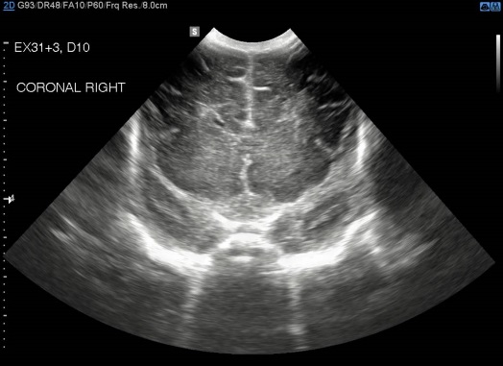
Coronal view of brain at level of MCAs
Include the entire depth of the brain in image
Demonstrate the MCAs, frontal horns of lateral ventricles, corpus callosum
Identify presence/absence parenchymal haemorrhage
Labelled CORONAL RIGHT (right must be on anatomical right of patient)

Plane 2 – CORONAL AT LEVEL OF THIRD VENTRICLE
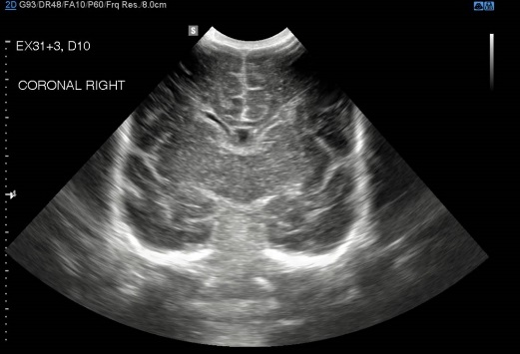
Coronal view of brain at level of the third ventricle
Include the entire depth of the brain in image
Demonstrate the third and lateral ventricles, corpus callosum, caudate nucleus, CSP, Sylvian fissures
Identify presence/absence of subependymal haemorrhage (SEH), intraventricular haemorrhage (IVH) and parenchymal haemorrhage
Labelled CORONAL RIGHT (right must be anatomical right of patient)

Plane 3 – CORONAL AT LEVEL OF TENTORIUM CEREBELLI

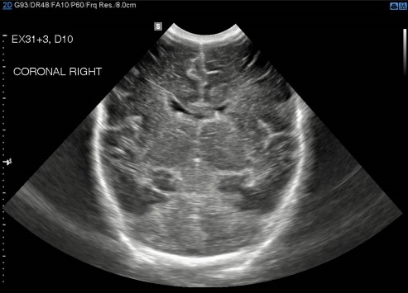
Coronal view of brain at level of the tentorium
Include the entire depth of the brain in image
Demonstrate the tentorium cerebelli, lateral ventricles and falx cerebri
Identify presence/absence of IVH and parenchymal haemorrhage
Labelled CORONAL RIGHT (right must be anatomical right of patient)

Plane 4 – CORONAL OF POSTERIOR PARENCHYMA

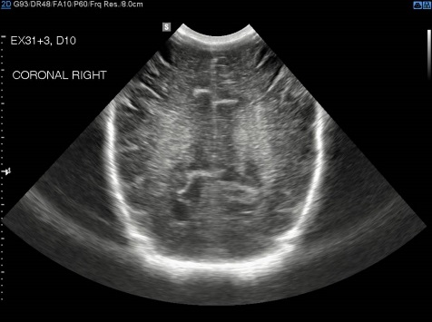
Coronal view of the posterior parenchyma of the brain
Include the entire depth of the brain in image
Demonstrate the falx cerebri, occipital lobe
Identify presence/absence of parenchymal haemorrhage
Labelled CORONAL RIGHT (right must be anatomical right of patient)

Plane 5– RIGHT SAGITTAL CAUDOTHALAMIC (CT) GROOVE

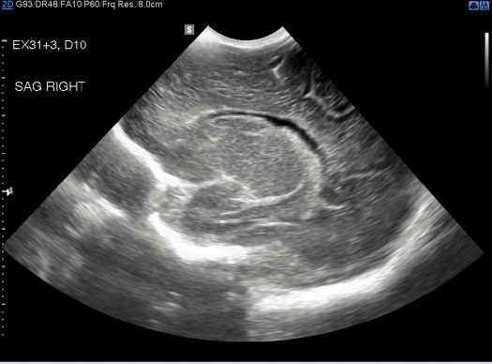
Longitudinal view right sagittal CT groove
Include the entire depth of the brain in image
Demonstrate the ventricle, caudate nucleus, thalamus and CT groove
Distinguish choroid from haemorrhage
Identify presence/absence of SEH, IVH and parenchymal haemorrhage

Labelled SAG RIGHT

Plane 6 – MID SAGITTAL

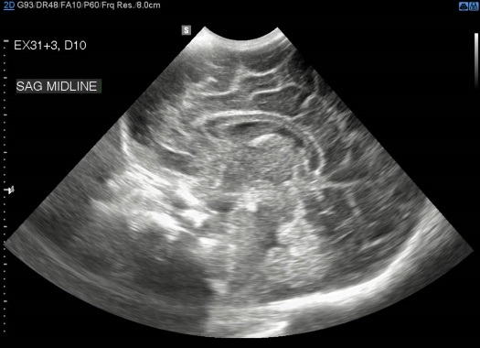
Longitudinal view midline brain
Include the entire depth of the brain in image
Demonstrate the corpus callosum, cerebellar vermis
Identify presence/absence of parenchymal haemorrhage

Labelled SAG MIDLINE

Plane 7 – LEFT SAGITTAL CAUDOTHALAMIC GROOVE
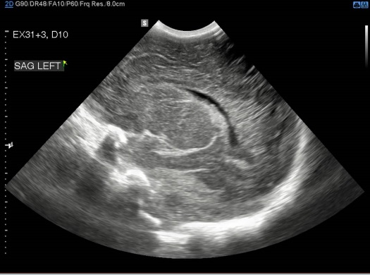
Longitudinal view left sagittal CT groove
Include the entire depth of the brain in image
Demonstrate the ventricle, caudate nucleus, thalamus and CT groove
Distinguish choroid from haemorrhage
Identify presence/absence of SEH, IVH and parenchymal haemorrhage

Labelled SAG LEFT

Practical Evaluation for Accreditation NICU Cranial Ultrasound
Evaluation
Completion in < 6 minutes
Satisfactory or Non-satisfactory only
Any score of 0 = Non-satisfactory
Scores 1 or 2 = Satisfactory
2 levels of Pass score for feedback & monitor areas for improvement

Name:

Hospital:

Date:

PoCUS Assessor:

Explains Examination: Can communicate this clearly to parents/nurse | 0  Incomplete or misinformation | 1  Explanation complete but brief | 2  Full explanation with indication and limitations
Entry of Patient Details, Selection of Transducer & Examination Preset | 0  Unable to complete task completely | 1  Task completed but  with hesitancy | 2  Utilises equipment & preset confidently & appropriately
Image optimisation (depth, gain, TGC, focus) | 0  Suboptimal image quality | 1  Optimizes image but uncertainty using controls | 2  Optimizes image confidently  & appropriately
Coronal Views – | 0  Unable to correctly demonstrate anatomy | 1  Anatomy demonstrated but unsystematic approach | 2  Systematic approach in demonstrating all anatomy
Sagittal Views – | 0  Unable to correctly demonstrate anatomy | 1  Anatomy demonstrated but unsystematic approach | 2  Systematic approach in demonstrating all anatomy
Documentation of Examination | 0  Incorrect/inadequate documentation of imaging series | 1  Correct documentation but suboptimal scan plane | 2  Documentation as per protocol
Interpretation of Sonographic Appearances  (Anatomy, Pathology, Artefacts) | 0  Unable to interpret ultrasound appearances  correctly | 1  Correct but some hesitancy interpreting appearances | 2  Correct and confident interpretation of appearances

QUALITY AUDITING

Cranial module examinations will be regularly audited by PoCUS program sonographer educators for technical and diagnostic accuracy. Reference to correlative imaging, surgical and clinical findings will be made when available. Audit results will be recorded in e-logbooks for clinician quality feedback. A coloured ‘traffic light’ system of visual quality feedback will be used (see details below) with further audit comments as required.

All cases with significant error or quality problems (false positive and false negative) will be reported to Director of Ultrasound and NICU PoCUS committee for review. Immediate feedback by email or in person, will be given by program sonographer for such cases. The NICU PoCUS committee will follow up issues of repeated poor quality or program non-compliance.

 | ELOGBOOK QUALITY AUDIT FEEDBACK SYSTEM
3 | good scan, accurate diagnosis & technical quality
2 | minor technical errors, see comments, no misdiagnosis
1 | false negative
0 | false positive

GREEN flag will be recorded for an examination with correct scan planes, adequate sonographic anatomy visualised for each view and correct clinician interpretation, as detailed in scan audit criteria below.

ORANGE flag (with audit comments) will be recorded for any incorrect scan planes, suboptimal demonstration of anatomy or suboptimal technical settings, as detailed in scan audit criteria.

RED flag (with audit comments) will be recorded for any false positive or false negative scan findings, whether from technical or interpretive errors, as verified by correlative imaging or other findings. Review of significant false positive/ false negative cases will be made by PoCUS committee & Director of Ultrasound as required.

References:

Kluckow M (2014) Use of ultrasound in the hemodynamic assessment of the sick neonate. Arch Dis Child Fetal Neonatal Ed 99(4):F332–7

Rath C, Suryawanshi P. Point of Care Neonatal Ultrasound - Head, Lung, Gut and Line Localization. Indian Pediatr. 2016 Oct 8; 53(10):889-899. Epub 2016 Jul 1.

Harabor A, Soraisham S (2015) Utility of targeted neonatal echocardiography in the management of neonatal illness. J Ultrasound Med 34:1259–1263

Evans N, Gournay V, Cabanas F, Kluckow M, Leone T, Groves A, et al. Point-of-care ultrasound in the neonatal intensive care unit: international perspectives. 2011; 16:61-8.

Australian Society of Ultrasound in Medicine (ASUM) Policy B8 Statement on the Use of Ultrasound by Medical Practitioners 2008; Crows Nest, NSW.

Australian Society of Ultrasound in Medicine (ASUM) CCPU Syllabus Neonatal Ultrasound 2017; Crows Nest, NSW.

