Training & Accreditation in Physician Performed Ultrasound
LIMITED ABDO (ascites)

Purpose of Document

This document describes the process for credentialing Gastroenterology Registrars/Consultants within Monash Health (MH) to perform limited abdominal ultrasound for ascites and guided paracentesis.
The purpose of this module is to train and credential users in ultrasound guidance (marking) for ascitic taps. Procedural aspects of paracentesis are not included.

Background
Physician performed Point of Care ultrasound (PoCUS) has become an accepted part of clinical management, enabling rapid patient management decisions and guidance for interventional procedures. Gastroenterology Unit patients with chronic liver disease commonly present with recurrent ascites requiring drainage.
Ultrasound is a valuable tool for the detection of free intra-peritonal fluid (ascites) and for the procedural guidance of paracentesis (ascitic tap) procedures.(Ennis 2014) The utility of bedside abdominal US for the identification of free intra-peritoneal fluid and drainage of ascites has been recognized since the 1980’s. Improved accuracy of needle placement using ultrasound may reduce the risk of complications, length of stay and associated costs. (Mercaldi 2013)
A PoCUS training and credentialing program was established in 2011 to support the use of ultrasound by clinicians in Monash Health. The Gastroenterology project was initially piloted in 2019. Training is typically undertaken in the MHTP Complex Liver Clinic, requiring two Clinic sessions for skills training and completion of credentialing.
This document describes:
- A 3 stage process for accrediting physicians to perform Limited Abdo ultrasound
- Introductory education session
- Skills Development / Logbook / MH Accreditation
- Ongoing Quality Audit / Skills Maintenance
- A method for auditing scan quality, maintaining a MH logbook and ongoing accreditation

- A direct observational competency assessment of the skills necessary to perform ultrasound examinations to guide paracentesis.

STAGE 1 - Introductory Training

Gastroenterology Registrars & Consultants intending to perform ultrasound guided paracentesis within MH are expected to complete:
- Introductory education session provided by PoCUS program covering ultrasound equipment, scan technique, ultrasound anatomy & diagnostic pitfalls.
STAGE 2- Skill Development / eLogbook / MH Accreditation

Further development of ultrasound scanning skills is achieved through one-on-one training sessions with Sonographer educators, with the support of a PoCUS credentialed Gastroenterologist. Practical scanning support and feedback is provided throughout Stage 2.
- Credentialing requires completion of a minimum 10 scans, including 3 cases positive for ascites and marked for drainage
- Physicians are to record an adequate series of images as described in examination protocols
- Physician must complete a record of PoCUS scan findings for all examinations in EMR
(EMR > adhoc charting > PoCUS > Gastroenterology)
- All scans must be performed under correct patient ID
- All PoCUS scan images will be transmitted to Monash Imaging server for upload to PACS

Logbooks
EMR forms are required for adequate patient identification to upload scan images to PACS. This also enables maintainenance of electronic logbooks of scans for clinicians, clinical quality auditing and feedback. Physician logbooks are automatically generated and maintained by PoCUS program. Details of scans, clinician findings, credentialing status and quality auditing is reported regularly to Departmental heads.

Accreditation
Once minimum scan numbers are achieved, a brief practical competency assessment (direct observation of procedure) will be conducted by sonographer educator and supervising interventional radiologist / credentialed gastroenterologist.

STAGE 3: Ongoing Skills Maintenance

After completing the MH Accreditation process, the physician is able to perform ultrasound guided paracentesis within MH. In order to maintain MH credentials they are required to:
- Perform and log a minimum of 5 scans annually
- Undertake 1 hour of ultrasound education annually (such as practical skills refresher session, case review, online resources etc)
LIMITED ABDO Training & Evaluation

System Set-up
- Turn machine on, enter patient UR, surname & operator initials
- Select correct transducer (C5-1MHz)
- Select correct exam preset (ABDO/CHEST)

Transducer Positioning
- Orientation of transducer and correlation with image
- Demonstration of ability to manipulate the transducer to achieve the required images (sliding, fanning, rotating, heel-toe)

Image optimization
- Depth
- Gain /TGC
- Focal zone
- Color Doppler (scale, gain)

Image acquisition and interpretation ABDOMEN
- Identification of major abdominal anatomy including liver, kidneys, spleen, bowel, bladder
- Recognition of the presence of free fluid in peritoneum
- Recognition of the presence of pleural fluid in chest cavity
- Differentiation between simple ascites and complex fluid/blood/collections
- Differentiation between ascites and fluid filled urinary bladder, bowel loops or large cysts
- Identification of abdominal wall vessels using color doppler at site of marking for paracentesis

Recognition of artefacts and how to modify image accordingly:
- Increased attenuation of ultrasound beam due to patient habitus
- Shadowing; posterior enhancement; air artefacts

Integration of results to management of the patient
- Recognise any limitations of a scan & patients requiring formal imaging assessment
- Incorporate ultrasound findings with other clinical assessment of patient

LIMITED ABDO Protocol Image Series
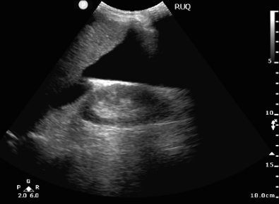

Right Upper Quadrant
  - Longitudinal view in right anterolateral abdomen
- Demonstrate liver, right kidney, bowel
- Identify presence/absence of ascites
- Label RUQ
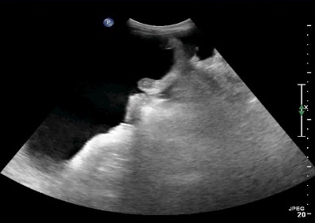
Right Iliac Fossa
- Longitudinal/oblique view in right iliac fossa
- Demonstrate right paracolic gutter, bowel, iliac vessels
- Identify presence/absence of ascites
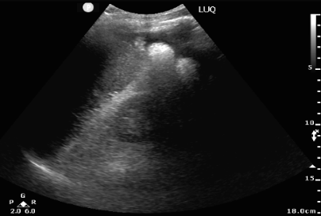
- Label RIF

Left Upper Quadrant
- Longitudinal view in left anterolateral abdomen
- Demonstrate spleen, left kidney, bowel
  - Identify presence/absence of ascites
  - Label LUQ
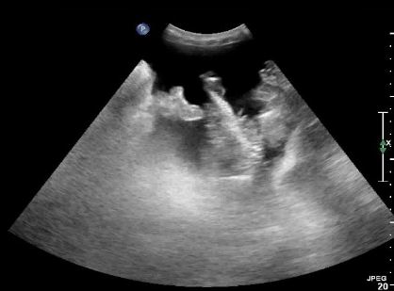

Left Iliac Fossa
- Longitudinal/oblique view in left iliac fossa
- Demonstrate left paracolic gutter, bowel, iliac vessels
- Identify presence/absence of ascites
- Label LIF
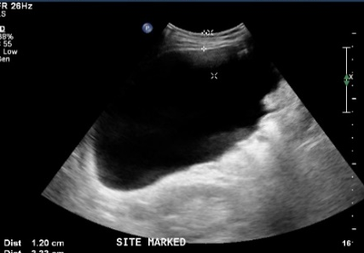

MARK SITE mesurements
- Perpendicular view at planned paracentesis site
- Measure skin - abdo wall depth & skin - mid ascites depth
- Label MARK SITE

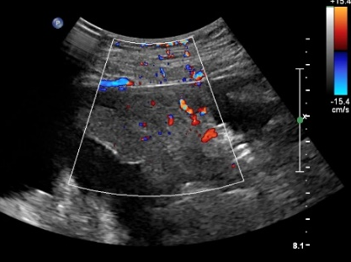
MARK SITE Color Doppler
- Reduce image depth to obtain view at planned paracentesis
Site, with color Doppler map over abdominal wall
- Recognise any inferior epigastric vessels or large varices

Practical Competency Assessment- LIMITED ABDOMEN
Evaluation
Completion in < 10 minutes
Satisfactory or Non-satisfactory only
Any score of 0 = Non-satisfactory
Scores 1 or 2 = Satisfactory
2 levels of Pass scores are for feedback and to monitor areas for improvement

Doctor Name:

Hospital:

Date:

Assessors:

Explains examination  & obtains patient consent | 0  Incomplete explanation/inadequate consent/misinformation | 1  Explanation/consent complete but very brief | 2  Full explanation/consent with indications & limitations
Entry of patient details, selection of transducer & examination presets | 0  Unable to complete task adequately | 1  Task completed but  with hesitancy | 2  Excellent knowledge of machine & settings
Image optimisation  (depth, gain/TGC, focus,  color doppler settings) | 0  Suboptimal image quality & poor image optimisation | 1  Optimizes images but  uncertainty using controls | 2  Optimizes images confidently & appropriately
RUQ view  demonstration & recognition of liver, diaphragm, kidney, bowel & ascites | 0  Incomplete or inaccurate demonstration of anatomy | 1  Anatomy demonstrated  with unsystematic approach or minor inaccuracies | 2  Systematic & accurate demonstration of anatomy
RIF view  demonstration & recognition of liver, kidney, bowel, bladder & ascites | 0  Incomplete or inaccurate demonstration of anatomy | 1  Anatomy demonstrated  with unsystematic approach or minor inaccuracies | 2  Systematic & accurate demonstration of anatomy
LUQ view  demonstration & recognition of spleen, diaphragm, kidney, bowel & ascites | 0  Incomplete or inaccurate demonstration of anatomy | 1  Anatomy demonstrated  with unsystematic approach or minor inaccuracies | 2  Systematic & accurate demonstration of anatomy
LIF view  demonstration & recognition of spleen, kidney, bowel, bladder & ascites | 0  Incomplete or inaccurate demonstration of anatomy | 1  Anatomy demonstrated  with unsystematic approach or minor inaccuracies | 2  Systematic & accurate demonstration of anatomy
ABDO MARK site – at deepest ascites pocket, accurate skin-depth measurement, Color Doppler wall assessment | 0  Incorrect imaging, mark position, measurements or color Doppler use | 1  Minor inaccuracy in imaging, mark position, measurements or color Doppler use | 2  Accurate imaging, mark position, measurements & color Doppler use

QUALITY AUDITING

Routine quality auditing will be conducted and scanning logbooks maintained by PoCUS program sonographer educators. Quality reports will be provided to Directors of Gastroenterology and Ultrasound. Ultrasound scans will be qualitatively assessed using a simple system assessing technical adequacy and diagnostic accuracy of examination, with reference to correlative imaging, surgical or clinical findings where available. Audit results and comments for clinician feedback will be provided in logbooks maintained for clinicians. Random audit of a minimum 3 examinations will be conducted yearly to ensure maintenance of scanning skills and quality.
eLOGBOOK QUALITY AUDIT FEEDBACK
3 | good scan, accurate diagnosis & technical quality
2 | technical errors, but no misdiagnosis
1 | false negative
0 | false positive

GREEN flag will be recorded for examinations with correct scan planes, adequate sonographic anatomy visualised for each view and correct clinician interpretation.
ORANGE flag (with audit comments) will be recorded for incorrect scan planes, suboptimal demonstration of anatomy, suboptimal technical settings or failure to complete EMR record of scan findings.
RED flag (with audit comments) will be recorded for any false positive or false negative scan findings, whether from technical or interpretive errors, as verified by correlative imaging or other findings.

AUDIT CRITERIA

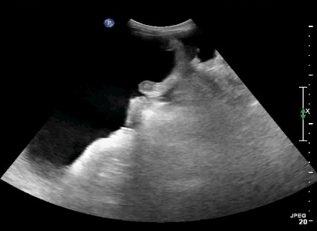
RUQ, RIF, LUQ, LIF QUADRANT VIEWS
- Longitudinal plane views obtained in four quadrants of the abdomen
- Curvilinear transducer on ABDO preset
- Demonstration of relevant anatomy including liver, spleen, kidney, bowel, urinary bladder and major vessels
- Correct identification of the presence/absence of ascites
- Depth - adequate if no portion of fluid within peritoneum is cut-off OR if
deepest portion of ascites is within the superficial half of the image field
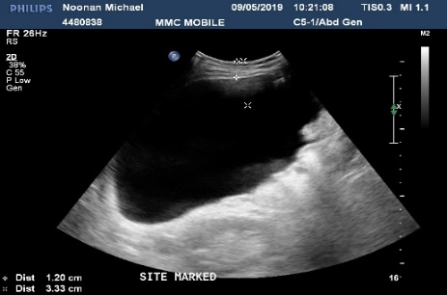
- Gain/TGC - adequate to demonstrate ascites without over-gain obscuring anatomy/ fluid OR under-gain making abdominal wall/solid organs appear anechoic
- Focal Zone - at midpoint of image field within +/- 5cm
- Labelled RUQ, LUQ, RIF, LIF as appropriate

MARKED SITE VIEW
- Perpendicular view at planned paracentesis tap site
- Accurately measured skin to ascites depth

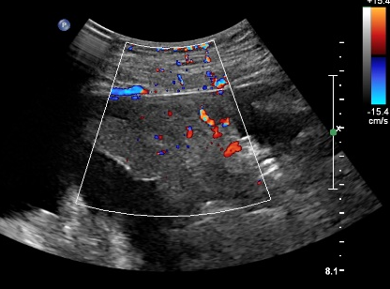
MARKED SITE COLOR VIEW

- View at planned paracentesis site with color Doppler map over abdominal wall
- Correct identification of vasculature (inferior epigastric vessels, large varices)
- Depth - adequate if abdominal wall and ascites <10 cm is displayed
- Doppler scale & gain -adequate if scale setting <20cm/s & gain sufficient to
detect vessels without color map bleeding over anatomy
References:

Australasian Society of Ultrasound in Medicine (2014) Policy B8 Statement on the Use of Ultrasound by Medical Practitioners. Crows Nest, NSW: ASUM (revised)

Australasian Society of Ultrasound in Medicine (2018) Hepatic Procedural CCPU Syllabus. Crows Nest, NSW: ASUM

Ennis J, Schultz G, Perera P et. al. Ultrasound for Detection of Ascites and for Guidance of the Paracentesis Procedure: Technique and Review of the Literature. International Journal of Clinical Medicine. 2014, 5;1277-1293.

Mercaldi C, Lanes S. Ultrasound Guidance Decreases Complications and Improves the Cost of Care Among Patients Undergoing Thoracentesis and Paracentesis. Chest. 2013; Vol 143; 2:532-538.

.

