Training & Accreditation in Point of Care Ultrasound
MODULE 4: LIMITED RUQ (BILIARY)
Purpose of Document

This document describes the process for credentialing Emergency Physicians within Monash Health to perform

- Limited Right Upper Quadrant (RUQ) biliary sonography for cholelithiasis and cholecystitis

Background

Physician performed ‘point of care’ ultrasound has become an accepted part of clinical management. The immediacy and availability of bedside ultrasound in a variety of clinical contexts means that patient management decisions can be informed and expedited.

Biliary disease is the third most common cause of acute abdominal pain in the Emergency department. (Cervellin 2016) Emergency patients presenting with RUQ or epigastric pain commonly require a Diagnostic Imaging department ultrasound before decisions to admit to a medical/ surgical unit or discharge can be made. (Miller 2006) Physician performed ultrasound enables accurate and timely management of patients with suspected cholelithiasis, ruling out cholelithiasis as the cause of RUQ pain by the absence of calculi in the gallbladder. (Jang 2010, Gaspari 2009)

The Australasian College for Emergency Medicine (ACEM) supports the use of focussed ultrasound examinations in the Emergency Department, stating that ultrasound imaging has been shown to enhance the Clinician’s ability to assess and manage patients with a variety of acute illnesses and injuries and focused bedside ultrasound examinations performed by trained Emergency Physicians in order to answer specific clinical questions have been shown to improve patient outcomes.(ACEM 2019, ASUM 2020) It has been acknowledged that RUQ biliary scanning is an appropriate use of ultrasound within MH Emergency departments. A collaborative MH Point of Care Ultrasound (PoCUS) program was established in 2011 to support excellence in physician-performed ultrasound.

This document describes:
- A 3 stage process for accrediting Emergency Physicians to perform RUQ biliary scans
- Initial Training
- Skill Development / Electronic Logbook / MH Accreditation
- Ongoing Audit / Maintaining Skill
STAGE 1 - Initial Training

ED Registrars and Consultants wishing participate in the advanced modules of the MH program must have completed credentialing in Module 1 eFAST scanning. The physician may commence RUQ module training via one-to-one sessions with Sonographer Educator, however attendance at MH Advanced course covering RUQ/RENAL/LUNG modules is recommended.

STAGE 2- Skill Development / Log Book / Accreditation

This stage requires the completion of a logbook which documents:
- 25 RUQ biliary examinations (5 examinations should be positive for cholelithiasis)
- An entry is only valid if the ED physician is the person performing the examination
- Multiple entries of same patient in the same episode of care by a physician is not acceptable
- Multiple PoCUS module scans performed on the one patient is acceptable and will be electronically logged for each module type conducted
- ED Physician is to record an adequate series of images as described in examination protocols
- Physician must complete EMR PoCUS adhoc charting of scan findings for all examinations performed
- EMR PoCUS workforms are necessary to document scan results, facilitate adequate patient identification for scans to be uploaded to PACS, generation of individual electronic logbooks and for program quality auditing
- All examination images will be transmitted to PoCUS program server for upload to PACS

Quality Auditing

Regular quality auditing will be conducted by PoCUS program sonographer educators with feedback to physicians for educational development purposes. Examinations will be qualitatively assessed using a simple system assessing technical adequacy and diagnostic accuracy of examination, with reference to correlative imaging, surgical or clinical findings where available. A coloured ‘traffic light’ system of visual quality feedback will be used with further audit comments as required.

Audit results and feedback comments will be provided in personal elogbooks maintained for clinicians. A minimum 25 examinations will be audited until a physician achieves MH credentialing. Thereafter, random audit of a minimum 5 examinations will be conducted yearly to ensure maintenance of skill and quality.

Cases with significant misdiagnosis or quality problems (false positive, false negative) will be reported to ED Ultrasound Governance group for review. Immediate feedback by email will be provided by program sonographer for such cases. The ED Governance group will follow up issues of repeated poor quality or program non-compliance.

eLOGBOOK QUALITY AUDIT FEEDBACK
3 | good scan, accurate diagnosis & technical quality
2 | technical errors, but no misdiagnosis, see comments
1 | false negative
0 | false positive

Green ‘traffic light’ will be recorded for an examination with correct scan planes, adequate sonographic anatomy visualised for each view and correct clinician interpretation.
Orange ‘traffic lights’ will be recorded for any incorrect scan planes, suboptimal demonstration of anatomy or suboptimal technical settings, as detailed in scan audit criteria below.
Red ‘traffic light’ will be recorded for any false positive or false negative scan findings, whether from technical or interpretive errors, as verified by correlative imaging or other findings.
Accreditation
Once logbook requirements (minimum scan numbers and positive cases) are completed, a brief direct observational competency assessment will be conducted by program Sonographer. Assessments for those wanting concurrent ASUM CCPU can also be completed at this time.

Alternative Accreditation Pathways
In certain select situations, alternative accreditation pathways may be considered for approval by ED Governance group.
- Fast tracked ‘grandfathering’ credentialing for clinicians with considerable prior experience, but no formal credentialing. This process would involve Monash Health program induction, practical competency assessment & the completion of a minimum of five quality reviewed scans, to be reviewed & considered for approval by committee.
- ASUM CCPU, DDU or other credential holders from external institutions. This process would involve Monash Health program induction, practical competency assessment & the completion of a minimum of five quality reviewed scans, to be reviewed & considered for approval by ED Governance group.
STAGE 3: Ongoing Skills Maintenance

After completing the MH Accreditation process, the Emergency Physician is able to perform eFAST scans within MH. In order to maintain MH credentials they are required to:
- Perform and log a minimum of 10 scans annually (no required number of positives)
- Undertake 3 hours of ultrasound education annually

RUQ Biliary Training & Evaluation

System Set-up
- Turn machine on
- Enter patient name & UR
- Select correct transducer (C5-2MHz) & preset

Transducer Positioning
- Orientation of transducer and correlation with image
- Demonstrates the ability to manipulate the transducer to achieve the required images (fanning, sliding, rocking, rotating)

Image optimization
- Gain/ TGC
- Depth
- Focal zone
- Zoom
- Color doppler map

Image interpretation
- Identify the liver, porta and gallbladder
- Recognise the presence of cholelithiasis (echogenic calculi seen within lumen with posterior shadowing)
- Differentiate between calculi and other entities (contracted gallbladder, gallbladder folds, Phrygian cap, bowel gas)
- Recognise the presence of cholecystitis (calculi, thickened gallbladder wall >3mm, pericholecystic fluid, sonographic Murphy’s sign)

Recognition of artefacts and how to modify image accordingly:
- Increased attenuation of ultrasound beam due to patient habitus
- Patient position, movement or respiration
- Shadowing from calculi, ribs and bowel
- Use Zoom magnification function

Integration of results to management of the patient
- Recognise the limitations of a scan and be able to explain these to patient/carer
- Recognise patients requiring formal imaging assessment
- Incorporate ultrasound findings with the rest of the clinical assessment (US results must be recorded in EMR PoCUS)

RUQ IMAGE SERIES

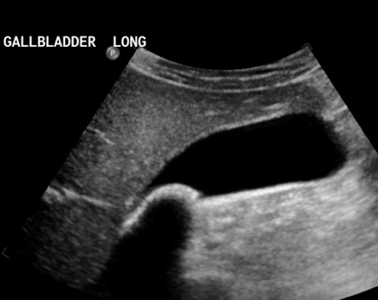
Plane 1 - Longitudinal GALLBLADDER
- Visualisation of the gallbladder in longitudinal plane (according to lie of gallbladder) in the most optimal patient position (ie. semi decubitus, lateral decubitus, supine, erect) to elongate gallbladder, or alternative intercostal approach as required
- Inclusion of neck, body and fundus
- Labelled GB LONG
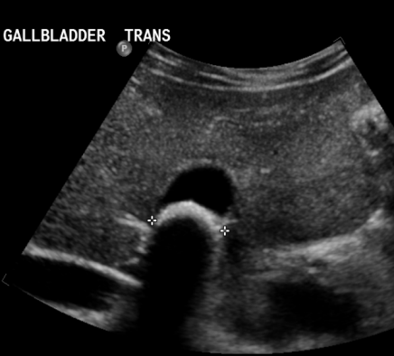

Plane 2 - Transverse GALLBLADDER
- Visualisation of the gallbladder in transverse plane (according to lie of gallbladder)
- Image mid body gallbladder if no calculi present, or at location of calculi if present
- Labelled GB TRANS

Gallbladder calculi should be confirmed in both longitudinal & transverse planes.

OPTIONAL VIEWS:

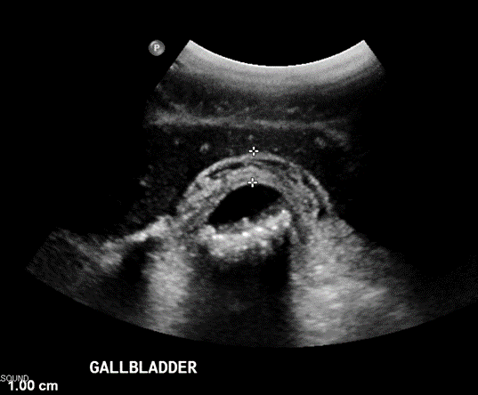
Plane 3 (optional) – GB WALL
- Visualisation of the gallbladder wall (in transverse plane ideally
- High detail image (zoomed)
- Near field wall measured outer to out wall, tightly positioned calipers (<3mm normal wall thickness)
- Labelled GB

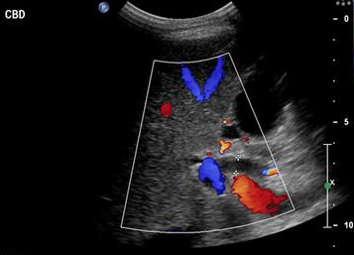
Plane 4 (optional) – CBD
- Visualisation of the common bile duct
- High detail image (zoomed)
- Use colour Doppler to confirm not MPV/HA
- Measured inner to inner wall, tightly positioned calipers (<6mm normal)
- Labelled CBD

Practical Competency Evaluation For Accreditation RUQ module

Physician name:
Evaluation
Completion in < 10 minutes
Satisfactory or Non-satisfactory only
Any score of 0 = Non-satisfactory
Scores 1 or 2 = Satisfactory
2 levels of Pass scores are for feedback and to monitor areas for improvement

Hospital:

Date:

Assessor:

Explanation of examination & patient consent | 0  Incomplete or misinformation | 1  Explanation complete but brief | 2  Full explanation with indication and limitations
Enter Patient Details  into Machine | 0  Unable to complete task completely | 1  Accurate but not familiar with machine | 2  Excellent knowledge of machine, accurate data input
Selection of transducer & examination presets | 0  Incorrect or unable to select appropriate settings | 1  Correct but some hesitancy in use of equipment | 2  Correct and confident use of equipment
Image optimisation  (depth, gain, TGC, zoom) | 0  Suboptimal image quality | 1  Optimizes image but hesitant use of machine functions | 2  Optimizes image appropriately with familiarity
Demonstration of  gallbladder | 0  Incomplete/inaccurate demonstration of GB | 1  Mostly demonstrated but unsystematic approach | 2  Systematic approach in demonstrating GB
Use of patient positioning (decubitus, erect) & transducer position  (subcostal, intercostal) | 0  Incomplete demonstration GB, poor patient or transducer positioning | 1  Limited use of patient or transducer positioning | 2  Good use of patient and transducer positioning  to demonstrate GB
Recognition of adjacent anatomy (liver, porta, CBD, IVC, bowel) | 0  Inaccurate recognition sonographic anatomy | 1  Mostly accurate recognition  sonographic anatomy | 2  Accurate recognition sonographic anatomy
Interpretation of  cholelithiasis & cholecystitis | 0  Misinterpretation of ultrasound appearances | 1  Correct but some hesitancy in interpreting appearances | 2  Correct and confident image interpretation
Documentation of examination | 0  Inappropriate images recorded | 1  Inconsistency in images recorded | 2  Consistently records correct images
Recognition of limitations and image artefacts | 0  Unable to recognise artefacts/ limitations | 1  Uncertainty in recognition of artefacts/ limitations | 2  Confidently recognises all artefacts/ limitations

RUQ AUDIT CRITERIA

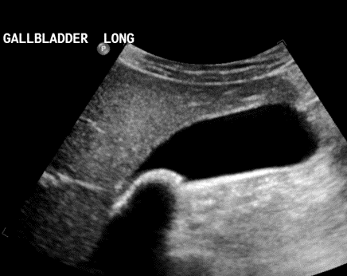
Longitudinal GALLBLADDER
-Longitudinal plane view of gallbladder
-Curvilinear transducer on RENAL/RUQ or ABDO preset
-Anatomy includes gallbladder neck, body & fundus without rib shadowing or bowel gas obscuring view (more than one image acceptable if required to demonstrate entire GB)
-Depth adequate if no portion of GB is cut-off OR deepest portion GB within superficial third of image field
-Gain/TGC adequate to demonstrate calculi without over-gain obscuring anatomy or causing artefact mimicking calculi OR under-gain making tissues anechoic
-Focal Zone at midpoint of image field +/- 5cm mid GB
Transverse GALLBLADDER
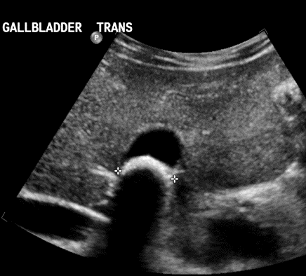
-Transverse (short axis) plane view of gallbladder
-Anatomy includes gallbladder body without rib shadowing or bowel gas obscuring view
-Depth adequate if no portion of gallbladder is cut-off OR deepest portion of gallbladder is within the superficial third of the image field
-Gain/TGC adequate to demonstrate calculi without over-gain obscuring anatomy OR under-gain making tissues appear anechoic
Focal Zone - at midpoint of image field within +/- 5cm mid GB

GB WALL (OPTIONAL)
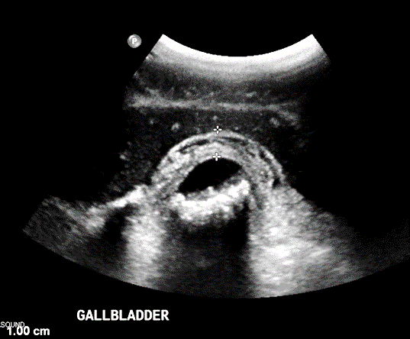
Visualisation of the gallbladder wall (in transverse or longitudinal plane)
High detail image (zoomed or reduced image depth)
GB wall measured outer to outer wall, tightly positioned calipers

CBD (OPTIONAL)

Visualisation of the common bile duct
High detail image (zoomed)
Use of colour Doppler to confirm not MPV/IVC/HA as required
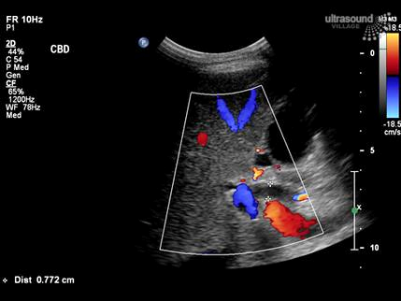
CBD measured inner to inner wall, tightly positioned calipers
Normal range <6mm normal, up to 10mm in elderly patient

References:

Cervellin G, Mora R, Ticinesi A. et al. Epidemiology and outcomes of acute abdominal pain in a large urban Emergency Department: retrospective analysis of 5,340 cases. Ann Transl Med 2016; 4 (19): 362

Miller A, Pepe P et.al. Emergency Department ultrasound in hepatobiliary disease J Emerg Med 2006; 30(1):69-74

Jang T, Ruggeri W et.al. The learning curve of resident physicians using emergency sonography for cholelithiasis and cholecystitis Acad Emerg Med 2010; 17(11):1247-52

Gaspari R, Dickman E et.al. Learning curve of bedside ultrasound of the gallbladder.J Emerg Med 2009; 37(1):51-56

ACEM (2019) P21 Policy - The use of focused ultrasound in Emergency Medicine. (revised) [online] Available at: https://acem.org.au/getmedia/000b84ee-378f-4b65-a9a7-c174651c2542/Feb_16_P21_Use_of_Focussed_US_in_EM.aspx [Accessed 23 Sep 2020]

ACEM (2019) P733 Policy - Credentialing for emergency medicine ultrasonography (revised) [online] Available at: https://acem.org.au/getmedia/ee68a734-7634-425d-865a-f5e17dc8b4e4/P733_Policy-on-Credentialing-for-Emergency-Medicine-Ultrasonography_v1_Aug-2019 [Accessed 23 Sep 2020]

ASUM (2020) Certificate of clinician Performed Ultrasound (CCPU) Biliary module (revised) [online] Available at: https://www.asum.com.au/files/public/Education/CCPU/Syllabi/CCPU-Biliary-Syllabus.pdf

