Training & Accreditation in Emergency Ultrasound
MODULE 7: LIMITED DVT

Purpose of Document

This document describes the process for credentialing Emergency Physicians within Monash Health (MH) to perform Point of Care ultrasound (PoCUS)

- Limited Sonography for Above Knee Lower Limb Deep Vein Thrombosis (DVT)
Background

DVT is a common disease in patients presenting to Emergency departments with potential for significant mortality and morbidity. At least one third of patients with untreated above knee DVT experience clinically significant pulmonary embolism and the short term mortality exceeds 20%. (Calder 2005) Pulmonary embolism is the third most common cause of death in cardiovascular disease after myocardial infarction and stroke. (Cushman 2017) Physician performed DVT scans enable rapid triage and management of patients, reducing the risks of unnecessarily anti coagulating patients without DVT and facilitating immediate hospital admission of patients with above knee DVT. (Burnside 2008)

The Australasian College for Emergency Medicine (ACEM) supports the use of focussed ultrasound examinations in the Emergency Department, stating that ultrasound imaging has been shown to enhance the Clinician’s ability to assess and manage patients with a variety of acute illnesses and injuries and focused bedside ultrasound examinations performed by trained Emergency Physicians in order to answer specific clinical questions have been shown to improve patient outcomes. (ACEM 2019) The Australasian Society for Ultrasound in Medicine (ASUM) also supports the devolution of diagnostic ultrasound to the clinical specialties only where the necessary regulatory environment and infrastructure exist for the supervision of training in the medical and surgical specialties. (ASUM 2014)

The Monash Health PoCUS program was commenced in 2011 to provide training and credentialing for physicians utilising ultrasound within agreed scopes of practise. It has been acknowledged that limited DVT scanning is an appropriate use of ultrasound within MH Emergency departments.

This document describes:

- A 3 stage process for accrediting Emergency Physicians to perform DVT module scans
- Initial Training
- Skills Development / Electronic Logbook /MH Accreditation
- Quality Audit / Skills Maintenance
- A method for auditing scan quality, maintaining a MH electronic logbook and ongoing accreditation

- A practical evaluation consisting of a direct assessment of the skills necessary to obtain and record appropriate ultrasound images for a limited DVT examination

STAGE 1 - Initial Training

ED Registrars and Consultants wishing participate in the advanced modules of the Monash PoCUS program must have completed Monash Health credentialing in Module 1 EFAST scanning. The physician will meet with the Sonographer educator for one to one education and training. Advanced MH courses & Masterclasses are also provided to support skills training.

STAGE 2 - Skill Development / eLogbook / MH Accreditation

Clinicians who have undertaken MH internal courses will complete advanced modules practical skills development stage as part of ongoing program training. Clinicians who have completed an external training course will undertake one to training/ program induction with program Sonographer educators prior to commencing scanning at MH. Practical scanning support, mentoring and feedback is offered throughout the completion of Stage 2. Additional self-directed learning is expected including viewing e-learning tools, revising cases, journal reading and other online resources.

Stage 2 requires the completion of a logbook which documents a minimum of 15 DVT examinations:
- A minimum of 2 cases in logbook must be positive for proximal DVT
- An entry is only valid if the ED physician is the person performing the examination
- Multiple entries of same patient in the same episode of care is not acceptable
- ED Physician is to record an adequate DVT series of images as described in examination protocols
- Physician must complete EMR PoCUS workform of scan findings for all examinations performed
- EMR PoCUS workforms facilitates adequate patient identification, upload of scan images to PACS, generation of an electronic clinician logbook and quality auditing process based on documented scan findings
- All examination images will be transmitted to PoCUS program server for upload to Monash Imaging PACS

Quality Auditing

Regular quality auditing will be conducted by PoCUS program sonographer educators. Quality audit reports will be provided to ED PoCUS Governance group, including Directors of Ultrasound & Emergency. Examinations will be qualitatively assessed using a simple system assessing technical adequacy and diagnostic accuracy of examination, with reference to correlative imaging, surgical or clinical findings where available.

eLOGBOOK QUALITY AUDIT FEEDBACK
3 | good scan, accurate diagnosis & technical quality
2 | technical errors, but no misdiagnosis, see comments
1 | false negative
0 | false positive

Audit results and comments for clinician feedback will be provided in personal elogbooks maintained for clinicians (see also DVT Audit Guidelines). A minimum 15 DVT examinations will be audited until a physician achieves MH credentialing. Thereafter, random audit of a minimum 5 examinations will be conducted yearly to ensure maintenance of skill and quality.

Accreditation
Once logbook requirements (minimum scan numbers and positive cases) are completed, a brief practical competency assessment will be conducted by program Sonographer educator. Assessments and paperwork for those wanting to obtain concurrent ASUM CCPU can also be completed at this time.

Alternative Accreditation Pathways
In certain select situations, alternative accreditation pathways may be considered for approval by ED Governance group.
- Fast tracked ‘grandfathering’ credentialing for clinicians with considerable prior experience, but no formal credentialing. This process would involve Monash Health program induction, practical competency assessments in relevant modules & the completion of a minimum of five quality reviewed scans, to be reviewed & considered for approval by committee.
- ASUM CCPU, DDU or other credential holders from external institutions. This process would involve Monash Health program induction, practical competency assessment & the completion of a minimum of five quality reviewed scans, to be reviewed & considered for approval by ED PoCUS Governance group.

STAGE 3: Ongoing Skills Maintenance

After completing the MH Accreditation process, the Emergency Physician is able to perform limited DVT scans within MH. In order to maintain MH credentials they are required to:

- Perform and log a minimum of 10 DVT scans annually (no required number of positives)
- Undertake 3 hours of ultrasound education annually (including practical skills refresher sessions, case review, online resources)

DVT Module Training & Evaluation

Machine Set-up
- Turn machine on, enter patient UR, name, Dr initials
- Select correct transducer (L9-4MHz or C5-1MHz) & preset (Venous or Vascular)

Transducer Positioning
- Orientation of transducer and correlation with image
- Interchange between transverse and longitudinal planes
- Appropriate transducer pressure
- Demonstrates ability to manipulate the transducer to achieve required images (sliding, fanning, rotating, compression)

Image optimization
- Gain/ TGC
- Depth
- Focal zone
- Color doppler mode

Recognition of normal anatomy and landmarks
- Recognition of differences between arteries and veins
- Recognition of the CFV, SFJ, FV, POP V and CFA, SFA, POP A

Image interpretation
- Recognition of a normal vein, venous compression, colour flow with augmentation
- Recognition of venous variants – duplicated deep veins, large varicosities
- Identification of venous thrombus (no compression/colour flow) & proximal extension

Recognition of artefacts and how to modify image:
- Increased attenuation of ultrasound beam due to patient habitus or lower limb oedema
- Shadowing from calcified arteries
- Color doppler optimisation

Integration of results to patient management
- Recognise the limitations of a scan and be able to explain these to patient/ carer
- Recognise patients requiring formal imaging assessment
- Incorporate ultrasound findings with the rest of the clinical assessment
- Scan results must be recorded in EMR PoCUS workforms

Protocol DVT examination:

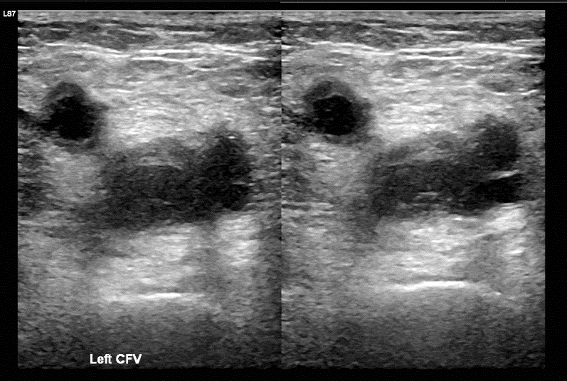
View 1 - Common Femoral Vein
- Visualization in the transverse plane proximal to sapheno-femoral junction at groin
- Dual screen with CFV uncompressed & compressed
- Labelled CFV

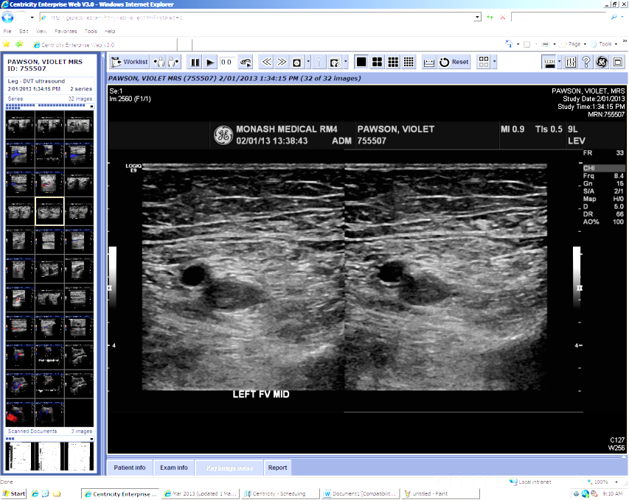
View 2 - Femoral Vein
- Visualization in the transverse plane at mid thigh
- Dual screen with CFV uncompressed & compressed
- Labelled FV

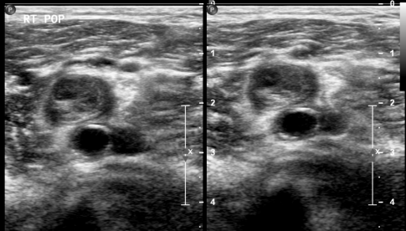

VIew 3 – Popliteal Vein
- Visualisation of the POP V at knee crease
- Dual screen with non-compressed and compressed view
- Labelled POP V

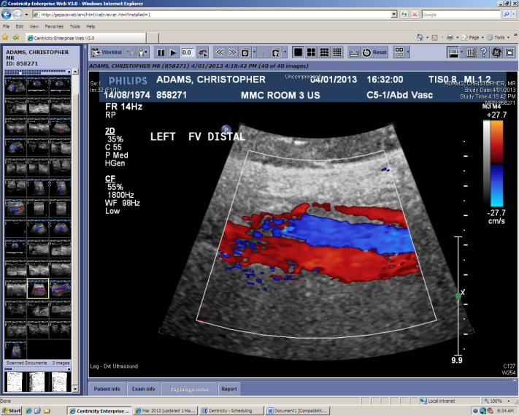
Colour Doppler Views (as required)
- Visualisation of CFV, FV or POPV must be assessed using colour Doppler imaging if difficult visualisation or poor compression
- Longitudinal scan planes demonstrating vessel with color map overlay
- Manual augmentation and vessel fill to confirm venous patency

Practical Competency Evaluation For Accreditation
Evaluation
Completion in < 5 minutes
Ccore of 0 = Non-satisfactory
Scores 1 or 2 = Satisfactory

DVT Module

Name:

Hospital: Date:
Explanation of examination & patient consent |  | 0  Incomplete or misinformation | 1  Hesitancy in explanation or obtaining consent |  | 2  Full explanation & patient consent obtained
Setup - patient details, transducer & presets |  | 0  Incomplete or incorrect examination setup | 1  Hesitancy in completing examination setup |  | 2  Accurate & complete examination setup
Image optimisation  (depth, gain, TGC, focus) |  | 0  Suboptimal image quality | 1  Optimizes image but uncertainty using controls |  | 2  Optimizes image confidently & appropriately
Common Femoral V views (groin) |  | 0  Incomplete or inaccurate demonstration | 1  Structures demonstrated but unsystematic approach |  | 2  Systematic approach in demonstrating all structures
Femoral V views  (mid thigh) |  | 0  Incomplete or inaccurate demonstration | 1  Structures demonstrated but unsystematic approach |  | 2  Systematic approach in demonstrating all structures
Popliteal V views  (knee crease) |  | 0  Incomplete or inaccurate demonstration | 1  Structures demonstrated but with hesitancy |  | 2  Systematic approach in demonstrating all structures
Recognition of image artefacts & diagnostic limitations |  | 0  Unable to recognise artefacts or limitations | 1  Hesitancy in recognition of artefacts or limitations |  | 2  Confidently recognises all artefacts & limitations
Demonstration of color doppler flow & venous augmentation | 0  Incomplete or inaccurate demonstration |  |  | 1  Hesitancy using color doppler & augmentation |  | 2  Confident use of color doppler & augmentation
Interpretation of  venous pathology | 0  Misinterpretation of ultrasound appearances |  |  | 1  Hesitancy in interpreting ultrasound appearances |  | 2  Correct and confident interpretation
Documentation of examination (images series, color doppler, EMR report) |  | 0  Incorrect images, color doppler or reporting | 1  Minor inaccuracy of imaging, color doppler or reporting |  | 2  Accurate imaging, color doppler and reporting

Quality Auditing
DVT module examinations will be routinely audited by PoCUS program sonographer educators for technical and diagnostic accuracy. Reference to correlative imaging, surgical and clinical findings will be made when available. Audit results will be recorded in logbooks for clinician quality feedback. A coloured ‘traffic light’ system of visual quality feedback will be used with further audit comments as required.
Cases with significant error or quality problems (false positive, false negative) will be reported to Director of Ultrasound and ED PoCUS Governance Group for review. Immediate feedback by email, logbooks or in person, will also be given by program sonographer educators.
eLOGBOOK QUALITY AUDIT FEEDBACK
3 | good scan, accurate diagnosis & technical quality
2 | technical errors, but no misdiagnosis
1 | false negative
0 | false positive

Green ‘traffic light’ will be recorded for an examination with correct scan planes, adequate sonographic anatomy visualised for each view and correct clinician interpretation.
Orange & yellow ‘traffic lights’ will be recorded for any incorrect scan planes, suboptimal demonstration of anatomy or suboptimal technical settings.
Red ‘traffic light’ will be recorded for any false positive or false negative scan findings, whether from technical or interpretive errors, as verified by correlative imaging or other findings.

References:
Calder K, Herbert M, Henderson S. The mortality of untreated pulmonary embolism in emergency department patients. Ann Emerg Med 2005; 45:302–10.

Cushman M, Tsai A, White R et al. Deep vein thrombosis and pulmonary embolism in two cohorts: the longitudinal investigation of thromboembolism etiology. Am J Med 2004; 117(1):19-25.

Burnside P, Brown M, Kline J. Systematic review of Emergency physician performed ultrasonography for lower extremity deep vein thrombosis. Acad Emerg Med 2008; 15(6):493-8.

ACEM (2019) P21 Policy on the use of Focussed Ultrasound in Emergency Medicine. (revised) [online] Available at: https://acem.org.au/getmedia/000b84ee-378f-4b65-a9a7-c174651c2542/Feb_16_P21_Use_of_Focussed_US_in_EM.aspx [Accessed 13 Jun. 2019]

ASUM (2014) Policy B8 Statement on the Use of Ultrasound by Medical Practitioners. Crows Nest, NSW: ASUM 2014 (revised). [online] Available at: http://www2.asum.com.au/wp-content/uploads/2015/09/B8-Policy.pdf [Accessed 13 Jun. 2019]

